rom: http://www.informationclearinghouse.info/article29407.htm

Israel and Libya: Preparing Africa for the “Clash of Civilizations”

By Mahdi Darius Nazemroaya
October 15, 2011 "Global Research " Under the Obama Administration the United States has expanded the "long war" into Africa. Barack Hussein Obama, the so-called "Son of Africa" has actually become one of Africa's worst enemies. Aside from his continued support of dictators in Africa, the Republic of Côte d'Ivoire (Ivory Coast) was unhinged under his watch. The division of Sudan was publicly endorsed by the White House before the referendum, Somalia has been further destabilized, Libya has been viciously attacked by NATO, and U.S. Africa Command (AFRICOM) is going into full swing.
The war in Libya is just the start of a new cycle of external military adventurism inside Africa. The U.S. now wants more military bases inside Africa. France has also announced that it has the right to militarily intervene anywhere in Africa where there are French citizens and its interests are at risk. NATO is also fortifying its positions in the Red Sea and off the coast of Somalia.
As disarray and turmoil are once again uprooting Africa with external intervention, Israel sits silently in the background. Tel Aviv has actually been deeply involved in the new cycle of turmoil, which is tied to its Yinon Plan to reconfigure its strategic surrounding. This reconfiguration process is based on a well established technique of creating sectarian divisions which eventually will effectively neutralize target states or result in their dissolution.
Many of the problems afflicting the contemporary areas of Eastern Europe, Central Asia, Southwest Asia, South Asia, East Asia, Africa, and Latin America are actually the result of the deliberate triggering of regional tensions by external powers.

- Sectarian division,
- ethno-linguistic tension,
- religious differences, and
- internal violence
have been traditionally exploited by the United States, Britain, and France in various parts of the globe. Iraq, Sudan, Rwanda, and Yugoslavia are merely a few recent examples of this strategy of "divide and conquer" being used to bring nations to their knees.
The Upheavals of Central-Eastern Europe and the Project for a "New Middle East"
The Middle East, in some regards, is a striking parallel to the Balkans and Central-Eastern Europe during the years leading up to the First World War.
In the wake of the First World War, the borders of the multi-ethnic states in the Balkans and Central-Eastern Europe were redrawn and reconfigured by external powers, in alliance with local opposition forces. Since the First World War until the post-Cold War period the Balkans and Central-Eastern Europe have continued to experience a period of upheaval, violence and conflict that has continuously divided the region.
For years, there have been advocates calling for a "New Middle East" with redrawn boundaries in this region of the world where Europe, Southwest Asia, and North Africa meet. These advocates mostly sit in the capitals of Washington, London, Paris, and Tel Aviv. They envisage a region shaped around homogenous ethno-religious states. The formation of these states would signify the destruction of the larger existing countries of the region. The transition would be towards the formation of smaller Kuwait-like or Bahrain-like states, which could easily be managed and manipulated by the U.S., Britain, France, Israel, and their allies.
The Manipulation of the First "Arab Spring" during World War I
The plans for reconfiguring the Middle East started several years before the First World War. It was during the First World War, however, that the manifestation of these colonial designs could visibly be seen with the "Great Arab Revolt" against the Ottoman Empire.
Despite the fact that the British, French, and Italians were colonial powers which had prevented the Arabs from enjoying any freedom in countries like Algeria, Libya, Egypt, and Sudan, these colonial powers managed to portray themselves as the friends and allies of Arab liberation.
During the "Great Arab Revolt" the British and the French actually used the Arabs as foot soldiers against the Ottomans to further their own geo-political schemes. The secret Sykes–Picot Agreement between London and Paris is a case in point. France and Britain merely managed to use and manipulate the Arabs by selling them the idea of Arab liberation from the so-called "repression" of the Ottomans.
In reality, the Ottoman Empire was a multi-ethnic empire. It gave local and cultural autonomy to all its peoples, but was manipulated into the direction of becoming a Turkish entity. Even the Armenian Genocide that would ensue in Ottoman Anatolia has to be analyzed in the same context as the contemporary targeting of Christians in Iraq as part of a sectarian scheme unleashed by external actors to divide the Ottoman Empire, Anatolia, and the citizens of the Ottoman Empire.
After the collapse of the Ottoman Empire, it was London and Paris which denied freedom to the Arabs, while sowing the seeds of discord amongst the Arab peoples. Local corrupt Arab leaders were also partners in the project and many of them were all too happy to become clients of Britain and France. In the same sense, the "Arab Spring" is being manipulated today. The U.S., Britain, France, and others are now working with the help of corrupt Arab leaders and figures to restructure the Arab World and Africa.
The Yinon Plan
The Yinon Plan, which is a continuation of British stratagem in the Middle East, is an Israeli strategic plan to ensure Israeli superiority. It insists and stipulates that Israel must reconfigure its geo-political environment through the balkanization of the Middle Eastern and Arab states into smaller and weaker states. [The first item, Yinon Plan, above is not a document reference, but more like an internet search, with perhaps 100 reference items. It is somewhat dynamic and substantially removes you, the reader, from needing to place full confidence in author Nazemroaya. The second item is, in some sense, a document reference to the plan itself – but expressed is English instead of Hebrew. It is titled “The Zionist plan for the Middle East”.]
Israeli strategists viewed Iraq as their biggest strategic challenge from an Arab state. This is why Iraq was outlined as the centerpiece to the balkanization of the Middle East and the Arab World. In Iraq, on the basis of the concepts of the Yinon Plan, Israeli strategists have called for the division of Iraq into a Kurdish state and two Arab states, one for Shiite Muslims and the other for Sunni Muslims. The first step towards establishing this was a war between Iraq and Iran, which the Yinon Plan discusses.
The Atlantic, in 2008, and the U.S. military's Armed Forces Journal, in 2006, both published widely circulated maps that closely followed the outline of the Yinon Plan. Aside from a divided Iraq, which the Biden Plan also calls for, the Yinon Plan calls for a divided Lebanon, Egypt, and Syria. The partitioning of Iran, Turkey, Somalia, and Pakistan also all fall into line with these views. The Yinon Plan also calls for dissolution in North Africa and forecasts it as starting from Egypt and then spilling over into Sudan, Libya, and the rest of the region.

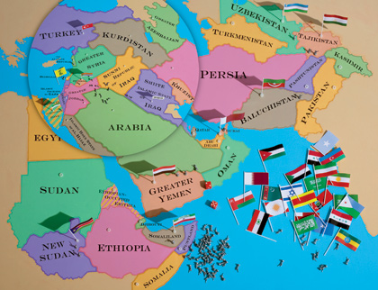
Note: The following [preceeding] map was drawn by Holly Lindem for an article by Jeffery Goldberg. It was published in The Atlantic in January/February 2008.
Map Copyright: The Atlantic, 2008.

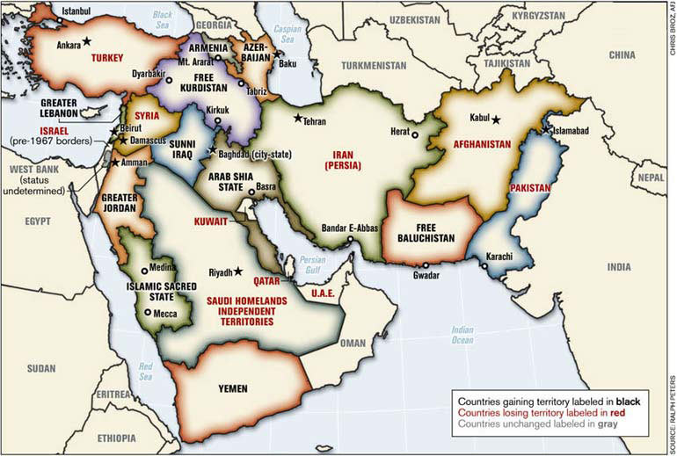
Note: The following [preceeding?] map was prepared by Lieutenant-Colonel Ralph Peters.
It was published in the Armed Forces Journal in June 2006, Peters is a retired colonel of the U.S. National War Academy.
Map Copyright Lieutenant-Colonel Ralph Peters 2006.

The Eradication of the Christian Communities of the Middle East
It is no coincidence that Egyptian Christians were attacked at the same time as the South Sudan Referendum and before the crisis in Libya. Nor is it a coincidence that Iraqi Christians, one of the world's oldest Christian communities, have been forced into exile, leaving their ancestral homelands in Iraq. Coinciding with the exodus of Iraqi Christians, which occurred under the watchful eyes of U.S. and British military forces, the neighbourhoods in Baghdad became sectarian as Shiite Muslims and Sunni Muslims were forced by violence and death squads to form sectarian enclaves. This is all tied to the Yinon Plan and the reconfiguration of the region as part of a broader objective.
In Iran, the Israelis have been trying in vain to get the Iranian Jewish community to leave. Iran's Jewish population is actually the second largest in the Middle East and arguably the oldest undisturbed Jewish community in the world. Iranian Jews view themselves as Iranians who are tied to Iran as their homeland, just like Muslim and Christian Iranians, and for them the concept that they need to relocate to Israel because they are Jewish is ridiculous.
In Lebanon, Israel has been working to exacerbate sectarian tensions between the various Christian and Muslim factions as well as the Druze. Lebanon is a springboard into Syria and the division of Lebanon into several states is also seen as a means to balkanizing Syria into several smaller sectarian Arab states. The objectives of the Yinon Plan are to divide Lebanon and Syria into several states on the basis of religious and sectarian identities for Sunni Muslims, Shiite Muslims, Christians, and the Druze. There could also be objectives for a Christian exodus in Syria too.
The new head of the Maronite Catholic Syriac Church of Antioch, the largest of the autonomous Eastern Catholic Churches, has expressed his fears about a purging of Arab Christians in the Levant and Middle East. Patriarch Mar Beshara Boutros Al-Rahi and many other Christian leaders in Lebanon and Syria are afraid of a Muslim Brotherhood takeover in Syria. Like Iraq, mysterious groups are now attacking the Christian communities in Syria. The leaders of the Christian Eastern Orthodox Church, including the Eastern Orthodox Patriarch of Jerusalem, have also all publicly expressed their grave concerns. Aside from the Christian Arabs, these fears are also shared by the Assyrian and Armenian communities, which are mostly Christian.
[Christian] Sheikh Al-Rahi was recently in Paris where he met President Nicolas Sarkozy. It is reported that the Maronite Patriarch and Sarkozy had disagreements about Syria, which prompted Sarkozy to say that the Syrian regime will collapse. Patriarch Al-Rahi's position was that Syria should be left alone and allowed to reform. The Maronite Patriarch also told Sarkozy that Israel needed to be dealt with as a threat if France legitimately wanted Hezbollah to disarm.
Because of his position in France, Al-Rahi was instantly thanked by the Christian and Muslim religious leaders of the Syrian Arab Republic who visited him in Lebanon. Hezbollah and its political allies in Lebanon, which includes most the Christian parliamentarians in the Lebanese Parliament, also lauded the Maronite Patriarch who later went on a tour to South Lebanon.
Sheikh Al-Rahi is now being politically attacked by the Hariri-led March 14 Alliance, because of his stance on Hezbollah and his refusal to support the toppling of the Syrian regime. A conference of Christian figures is actually being planned by Hariri to oppose Patriarch Al-Rahi and the stance of the Maronite Church. Since Al-Rahi announced his position, the Tahrir Party, which is active in both Lebanon and Syria, has also started targeting him with criticism. It has also been reported that high-ranking U.S. officials have also cancelled their meetings with the Maronite Patriarch as a sign of their displeasure about his positions on Hezbollah and Syria.
The Hariri-led March 14 Alliance in Lebanon, which has always been a popular minority (even when it was a parliamentary majority), has been working hand-in-hand with the U.S., Israel, Saudi Arabia, Jordan, and the groups using violence and terrorism in Syria. The Muslim Brotherhood and other so-called Salafist groups from Syria have been coordinating and holding secret talks with Hariri and the Christian political parties in the March 14 Alliance. This is why Hariri and his allies have turned on Cardinal Al-Rahi. It was also Hariri and the March 14 Alliance that brought Fatah Al-Islam into Lebanon and have now helped some of its members escape to go and fight in Syria.
A Christian exodus is being planned for the Middle East by Washington, Tel Aviv, and Brussels. It is now being reported that Sheikh Al-Rahi was told in Paris by President Nicolas Sarkozy that the Christian communities of the Levant and Middle East can resettle in the European Union. This is no gracious offer. It is a slap in the face by the same powers that have deliberately created the conditions to eradicate the ancient Christian communities of the Middle East. The aim appears to be the resettling of the Christian communities outside of the region so as to delineate the Arab nations along the lines of being exclusively Muslim nations. This falls into accordance with the Yinon Plan.
Re-Dividing Africa: The Yinon Plan is very Much Alive and at Work...
In the same context as the sectarian divisions in the Middle East, the Israelis have outlined plans to reconfigure Africa. The Yinon Plan seeks to delineate Africa on the basis of three facets:
(1) ethno-linguistics;
(2) skin-colour;
(3) religion.
It seeks to draw dividing lines in Africa between a so-called "Black Africa" and a supposedly "non-Black" North Africa. This is part of a scheme to create a schism in Africa between what are assumed to be "Arabs" and so-called "Blacks."
An attempt to separate the merging point of an Arab and African identity is underway.
This objective is why the ridiculous identity of an "African South Sudan" and an "Arab North Sudan" have been nurtured and promoted. This is also why black-skinned Libyans have been targeted in a campaign to "colour cleanse" Libya. The Arab identity in North Africa is being de-linked from its African identity. Simultaneously there is an attempt to eradicate the large populations of "black-skinned Arabs" so that there is a clear delineation between "Black Africa" and a new "non-Black" North Africa, which will be turned into a fighting ground between the remaining "non-Black" Berbers and Arabs.
In the same context, tensions are being fomented between Muslims and Christians in Africa, in such places as Sudan and Nigeria, to further create lines and fracture points. The fuelling of these divisions on the basis of skin-colour, religion, ethnicity, and language is intended to fuel disassociation and disunity in Africa. This is all part of a broader African strategy of cutting North Africa off from the rest of the African continent.
Israel and the African Continent
The Israelis have been quietly involved on the African continent for years. In Western Sahara, which is occupied by Morocco, the Israelis helped build a separation security wall like the one in the Israeli-occupied West Bank. In Sudan, Tel Aviv has armed separatist movements and insurgents. In South Africa, the Israelis supported the Apartheid regime and its occupation of Namibia. In 2009, the Israeli Foreign Ministry outlined that Africa would be the renewed focus of Tel Aviv.
Israel's two main objectives in Africa are to impose the Yinon Plan, in league with its own interests, and to assist Washington in becoming the hegemon of Africa. In this regard, the Israelis also pushed for the creation of AFRICOM. The Institute for Advanced Strategic and Political Studies (IASPS), an Israeli think-tank, is one example.
Washington has outsourced intelligence work in Africa to Tel Aviv. Tel Aviv is effectively involved as one of the parties in a broader war not just "inside" Africa, but "over" Africa. In this war, Tel Aviv is working alongside Washington and the E.U. against China and its allies, which includes Iran.
Tehran is working alongside Beijing in a similar manner as Tel Aviv is with Washington. Iran is helping the Chinese in Africa through Iranian connections and ties. These ties also include Tehran's ties to private Lebanese and Syrian business interests in Africa. Thus, within the broader rivalry between Washington and Beijing, an Israeli-Iranian rivalry has also unfolded within Africa. [1] Sudan is Africa's third largest weapons producer, as a result of Iranian support in weapons manufacturing. Meanwhile, while Iran provides military assistance to Khartoum, which includes several military cooperation agreements, Israel is involved in various actions directed against the Sudanese. [2]

Israel and Libya
Libya had been considered as "a spoiler" which undermined the interests of the former colonial powers in Africa. In this regard, Libya had taken on some hefty pan-African development plans intended to industrialize Africa and transform Africa into an integrated and assertive political entity. These initiatives conflicted with the interests of the external powers competing with one another in Africa, but it was especially unacceptable to Washington and the major E.U. countries. In this regard, Libya had to be crippled and neutralized as an entity supportive of African progress and pan-African unity.
The role of Israel and the Israeli lobby was fundamental in opening the door to NATO's military intervention in Libya. According to Israeli sources, it was U.N. Watch that actually orchestrated the events in Geneva to remove Libya from the U.N. Human Rights Council and to ask the U.N. Security Council to intervene. [3] U.N. Watch is formally affiliated with the American Jewish Committee (AJC), which has influence in the formulation of U.S. foreign policy and is part of the Israeli lobby in the United States. The International Federation of Human Rights (FIDH), which helped launch the unverified claims about 6,000 people being slaughtered by Qaddafi, is also tied to the Israeli lobby in France.
Tel Aviv had been in contact simultaneously with both the Transitional Council and the Libyan government in Tripoli. Mossad agents were also in Tripoli, one of which was a former station manager. At about the same time, French members of the Israeli lobby were visiting Benghazi. In a case of irony, the Transitional Council would claim that Colonel Qaddafi was working with Israel, while it made pledges to recognize Israel to president Sarkozy's special envoy Bernard-Henri Lévy who would then convey the message to Israeli leaders [4]. A similar pattern (to that of Israel's links to the Transitional Council) had also developed at an earlier stage in South Sudan, which was armed by Israel.
Despite the Transitional Council's position on Israel, its followers still tried to demonize Qaddafi by claiming he was secretly Jewish. Not only was this untrue, but it was also bigoted. These accusations were intended to be a form of character assassination that equated being a Jew as something negative.
In reality, Israel and NATO are in the same camp. Israel is a de facto member of NATO. Had Qaddafi been conniving with Israel while the Transitional Council was working with NATO, this would mean that both sides were actually being played as fools against one another.
Preparing the Chessboard for the "Clash of Civilizations"
It is at this point that all the pieces have to be put together and the dots have to be connected.
The chessboard is being staged for a "Clash of Civilizations" and all the chess pieces are being put into place.
The Arab World is in the process of being cordoned off and sharp delineation lines are being created. These lines of delineation are replacing the seamless lines of transition between different ethno-linguistic, skin-colour, and religious groups.
Under this scheme, there can no longer be a melding transition between societies and countries. This is why the Christians in the Middle East and North Africa, such as the Copts, are being targeted. This is also why black-skinned Arabs and black-skinned Berbers, as well as other North African population groups which are black-skinned, are facing genocide in North Africa.
What is being staged is the creation of an exclusively "Muslim Middle East" area (excluding Israel) that will be in turmoil over Shiite-Sunni fighting. A similar scenario is being staged for a "non-Black North Africa" area which will be characterized by a confrontation between Arabs and Berber. At the same time, under the "Clash of Civilizations" model, the Middle East and North Africa are slated to simultaneously be in conflict with the so-called "West" and "Black Africa."
This is why both Nicolas Sarzoky, in France, and David Cameron, in Britain, made back-to-back declarations during the start of the conflict in Libya that multiculturalism is dead in their respective Western European societies. [5]
Real multiculturalism threatens the legitimacy of the NATO war agenda. It also constitutes an obstacle to the implementation of the "Clash of Civilizations" which constitutes the cornerstone of U.S. foreign policy.
In this regard, Zbigniew Brzezinski, former U.S. National Security Advisor, explains why multiculturalism is a threat to Washington and its allies: "[A]s America becomes an increasingly multicultural society, it may find it more difficult to fashion a consensus on foreign policy issues [e.g., war with the Arab World, China, Iran, or Russia and the former Soviet Union], except in the circumstances of a truly massive and widely perceived direct external threat. Such a consensus generally existed throughout World War II and even during the Cold War [and exists now because of the 'Global War on Terror']." [6]
Brzezinski's next sentence is the qualifier of why populations would oppose or support wars: "[The consensus] was rooted, however, not only in deeply shared democratic values, which the public sensed were being threatened, but also in a cultural and ethnic affinity for the predominantly European victims of hostile totalitarianisms." [7]
Risking being redundant, it has to be mentioned again that it is precisely with the intention of breaking these cultural affinities between the Middle East-North Africa (MENA) region and the so-called "Western World" and sub-Saharan Africa that Christians and black-skinned peoples are being targeted.
Ethnocentrism and Ideology: Justifying Today's "Just Wars"
In the past, the colonial powers of Western Europe would indoctrinate their people. Their objective was to acquire popular support for colonial conquest. This took the form of spreading Christianity and promoting Christian values with the support of armed merchants and colonial armies.
At the same time, racist ideologies were put forth. The people whose lands were colonized were portrayed as "sub-human," inferior, or soulless. Finally, the "White Man's burden" of taking on a mission of civilizing the so-called "uncivilized peoples of the world" was used. This cohesive ideological framework was used to portray colonialism as a "just cause." The latter in turn was used to provide legitimacy to the waging of "just wars" as a means to conquering and "civilizing" foreign lands.
Today, the imperialist designs of the United States, Britain, France, and Germany have not changed. What has changed is the pretext and justification for waging their neo-colonial wars of conquest. During the colonial period, the narratives and justifications for waging war were accepted by public opinion in the colonizing countries, such as Britain and France. Today's "just wars" and "just causes" are now being conducted under the banners of women's rights, human rights, humanitarianism, and democracy.
Mahdi Darius Nazemroaya is a Sociologist and Research Associate of the Centre for Research on Globalization (CRG), Montréal. He specializes on the Middle East and Central Asia. He was on the ground in Libya for over two months and was also a Special Correspondent for Flashpoints, which is a program based in Berkeley, California. Nazemroaya has been releasing these articles about Libya in conjunction with aired discussions with Cynthia McKinney on Freedom Now, a show aired on KPFK, Los Angeles, California.
NOTES
[1] The Economist, "Israel and Iran in Africa: A search for allies in a hostile world," February 4, 2011.
[2] Ibid.
[3] Tova Lazaroff, "70 rights groups call on UN to condemn Tripoli," Jerusalem Post, February 22, 2011.
[4] Radio France Internationale, "Libyan rebels will recognise Israel, Bernard-Henri Lévy tells Netanyahu," June 2, 2011.
[5] Robert Marquand,"Why Europe is turning away from multiculturalism," Christian Science Monitor, March 4, 2011.
[6] Zbigniew Brzezinski, The Grand Chessboard: American Primacy and Its Geostrategic Imperatives (New York: Basic Books October 1997), p.211
[7] Ibid.

ANNEX I: MAP OF DIFFERENT WORLD CIVILIZATIONS REFLECTING SAMUEL HUNTINGTON'S MODEL
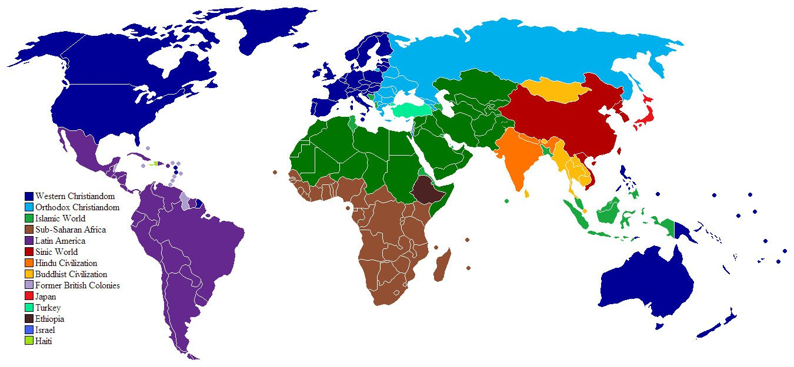
* These civilizational divisions and categories are incorrect. There are no clearcutting divisions between many of these so-called and supposedly "distinct civilizations."

ANNEX II: MODEL OF SAMUEL HUNTINGTON'S "CLASH OF CIVILIZATIONS"
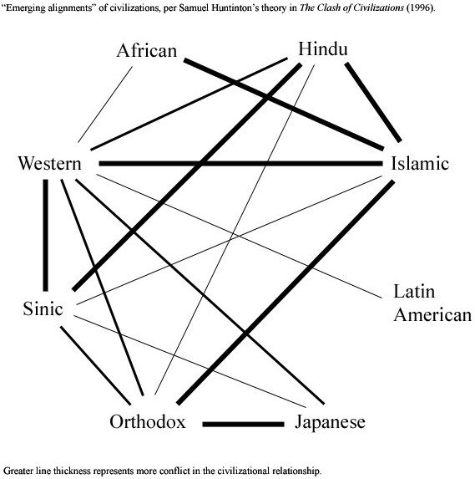
Copyright © Mahdi Darius Nazemroaya, Global Research, 2011

Scroll down to add your comments

